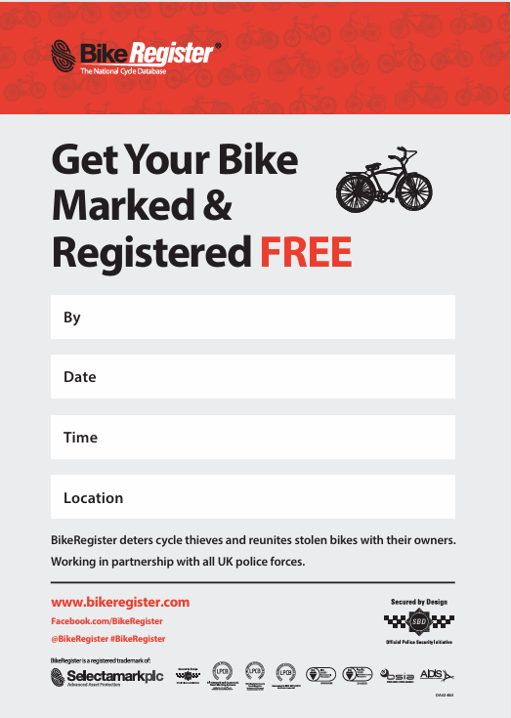
Newport Neighbourhoods Team
PCSO’s from Newport Neighbourhoods Team will be holding a FREE Bike Registering Event.

Pan Park 10:30 AM to 11:00 AM
Newport Quay 11:15 AM to 11:45 AM
Victoria Recreational ground 12AM to 12:30AM

This will provide members of the community with cycle security advice and secure marking / registration onto BikeRegister online database.

Registering your bike helps the police identify and verify the legitimate owner if it has been stolen or being resold.

If your 16 years and under please bring an adult

Sunday 5th July 2026
See attached individual times
See attached individual locations
FREE Bike registering event in Newport

