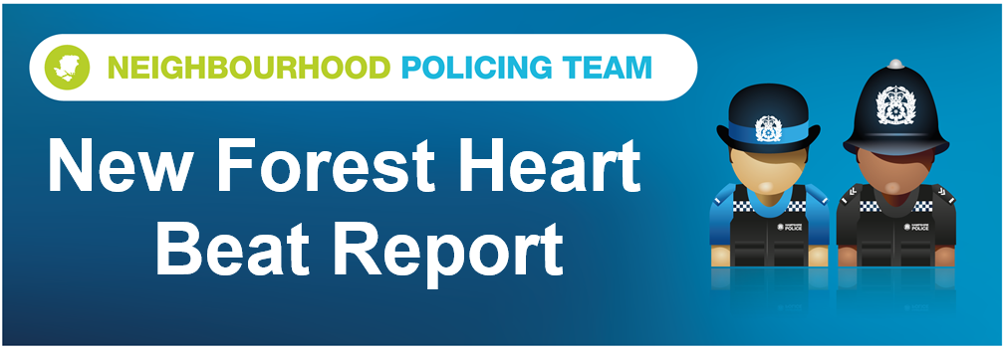

Hello and welcome to the September 2026 Beat Report for the New Forest Heart area. Your team is PC 24901 Mark ROBERTS, PC 27901 Stuart READHEAD and PCSO 14495 Richard WILLIAMS.
In October join us at one of our Beat Surgeries across the area – On Monday 5th October we will at the Ashurst and Colbury Community Day between 4pm and 7pm at the Happy Cheese Pub in Ashurst. There will be lots of different organisations on hand giving out lots of advice on staying safe at home and on line. We will be offering a free security property marking service so bring one of your valuable items with you and we will show you what to do and give you a marking kit that you can use on up to 50 other items.
We will also be giving out these property marking kits on Saturday 17th October between 9am and 11am at Lyndhurst Police Station and on Sunday 18th October we will be outside Totton Police station between 11am and 1pm. If you can’t make one of these sessions please email richard,williams@hampshire.police.uk and we will let you know about other events being held at different venues.
On Tuesday 27th October we are holding another one of our security bike marking sessions at the Boost Bike Hub in Brockenhurst – bring your bike to us and we will mark it for you and add it to the national bike register.
On Tuesday 6th October we will be at the Bartley Post Office at 9am and then back at the Happy Cheese Pub in Ashurst with the Ashurst and Colbury Neighbourhood watch team at 11am. Then on Wednesday 16th October we will be at the Lyndhurst Parish Council office in the Community Centre in the village from 11am and then an hour later at midday on Brookley Road in Brockenhurst.
Finally Thursday 8th October sees us at the East Boldre Community Coffee Club in the village shop from 2pm.
Remember our Beat Surgeries last for 30 minutes or more if necessary
Lets start with some good news, two New Forest men have been jailed for a combined total of 11 years and 5 months after pleading guilty to offences including conspiracy to commit dwelling burglary with intent to steal and conspiracy to steal. Billy Ridout, 29, of Headley Close in Fawley and Thomas Anthony Wellman, 29, of Rushpole Court, Dibden were sentenced following a vehicle and burglary related theft series in the New Forest between June 2025 and January 2026. A total of more than £100,000 worth of property was reported stolen from multiple victims. As well as the above Wellman had 20 further burglary and theft offences taken into consideration. These are offences that he was not charged with but has admitted and were considered as part of the overall sentencing.
Seven vehicles have been broken into this month and valuable items stolen from inside – in one car that was parked in the Knightwood Oak car park a handbag was taken and the cards were used within 30 minutes of the theft and nearly £1,000 was stolen. The other vehicles targeted this month were parked in Brock Hill and Latchmoor car parks and the Rhinefield House hotel.
Several hundred pounds worth of damage had been caused to a hut used to store tools on a remote site in a wooded area of Bramshaw and Brook – we think that children are responsible so if you know anything that would help us to stop this happening again and you live in the Canterton Lane area of Brook please get in touch. Criminal damage has also been caused to a side gate in Ashurst, which probably happened during an attempt to break in.
Sheds on the allotments in Ashurst and gardens in Lyndhurst and Brockenhurst have been broken into and the usual tools and garden equipment stolen, while other thefts this month include iron radiators from the site of the old Ashurst hospital, 700 litres of diesel from a site on the Bolderwood road and planters have been taken from a grave at St Mary’s Church in Copythorne. Two electric bicycles have also been stolen from the main Brookley Road in Brockenhurst,
There have also been seven shopliftings this month, all of them in Brockenhurst, two at the Tesco and the others at the Co Op.
On 18 September we were joined partners from Forestry England, the National Park Authority and DVSA for a commercial vehicle compliance operation at Yew Tree Car Park
- 51 vehicles stopped and checked
- All vehicles, trailers and plant machinery examined
- 3 vehicles dealt with for tyre-related offences
- No stolen vehicles, trailers or plant machinery identified
Drivers were also given advice on reporting animal collisions in the Forest, as well as preventing tool and bike theft. We want to thank our partners for their support in keeping our roads safe and helping to prevent crime in the local area.
Four tickets were issued to drivers for exceeding 50mph across the New Forest during this month’s Op Mountie sessions at Crockford Clump and Hawk Hill. Op Mountie is our muilti agency approach to reducing speed and animal accidents across the New Forest. Our partners at Forestry England, the National Park Authority and the New Forest Roads Awareness Team spoke to another six drivers about why it is so important to stick to the speed limit especially on Forest roads - we have recently had two more ponies hit by vehicles and killed. This month’s tickets were issued for speeds of 50, 52 and 55mph, and of the nine people stopped seven were locals. Again thanks to the vast majority of drivers who went passed us at or below the speed limit – we are always extremely grateful
Stay safe everyone
richard.williams@hampshire.police.uk
07554 775469

mark.roberts.2@hampshire.police.uk
07392 314340



