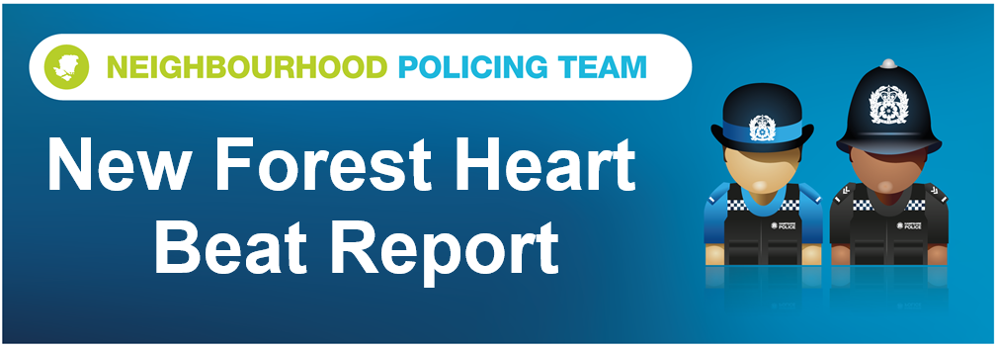

Hello and welcome to the July 2026 Beat Report for the New Forest Heart area. Your team is PC 24901 Mark ROBERTS, PC 27901 Stuart READHEAD and PCSO 14495 Richard WILLIAMS.
In August because it’s the holiday season for most of us, including the New Forest Heart Police Team, we don’t hold any of our usual Beat Surgeries but as we always say if you need to speak to us you can always call or email us, but to report a crime or any anti-social behaviour dial 101 or go the Hampshire and IOW Police website. Of course if it’s an emergency always call 999. Normal service will be resumed in September but we are holding several bike marking sessions in August across the Forest.
Bring your bikes to us and we will security mark them for you for free and add them to the National Bike Register. The dates in August are
Ringwood Gateway Town Centre on Thursday 13th August from 1pm to 2pm
Lymington Train Station on Wednesday 12th August from 10am to 11am
Lyndhurst Police station on Friday 14th August between 11am to midday
Totton Police station on Wednesday 19th August between 2pm and 3pm
Brockenhurst Bike Shop on Friday 21st August from 10am and 11am
In July six bicycles were stolen all from Brockenhurst. Two from a hotel car park and the other four from Brookley Road. These bikes were locked up but still stolen so often the best way to protect your bike is to take something with you, like a wheel or the saddle or leave one of your party with them. We regularly patrol the areas where most bikes are stolen from but of course we can’t be there all the time.
Four shopliftings were reported to us, three of them on the same day on the High Street in Lyndhurst and the other one at Tesco in Brockenhurst. We have some excellent CCTV footage and our investigations into identifying those responsible are on going
Attempts have also been made to steal from three vehicles parked overnight in the car park of a hotel on the Rhinefield Ornamental Drive, a motorbike from a pub car park in Emery Down and a van from a driveway in Cadnam. Cooking oil was also stolen from a pub also in Cadnam.
And a reminder to watch out for picket pockets at the summer shows and events that are coming up during the holidays – keep you wallets and purses close to your body at all times and never put anything valuable in your back pack because that makes stealing them really easy for thieves.
We are getting lots of reports of motorbikes being ridden off road in the Forest at Boltons Bench and behind the cemetery in Lyndhurst and on the roads around Ashurst, Woodlands and Fletchwood Lane. Please help us identify these riders so that we can stop them before someone gets hurt or more damage is caused to the New Forest. If you see one of these bikes going to and from a location in the area please let us know. You can email us directly or let us have the information completely anonymously via Crimestoppers, just go to their website for all the details. Thank you
We held another one of our multi-agency operations aimed at tackling vehicle crime, fly-tipping and improving road safety this month, this time at Crockford Clump Inclosure on the B3054 between Beaulieu and Lymington. The operation, known as Operation Wolf, brought together officers from Hampshire & Isle of Wight Constabulary, New Forest District Council and Forestry England. Operation Wolf was established in response to an increase in fly-tipping incidents across the New Forest and combines the powers and expertise of partner agencies to detect offences, disrupt criminal activity and deter those responsible. During the operation, 14 vehicles were stopped and checked. Two drivers were issued notices requiring them to produce a valid Waste Carrier Licence within the next 14 days. In addition to tackling waste-related offences, Operation Wolf provides opportunities to identify illegal vehicle use, check for stolen tools, trailers and plant machinery, and ensure vehicles using the road network are safe and roadworthy.
During July’s Op Mountie session we only stopped four motorists for breaking the 40 mph speed limit outside the Setthorns Campsite on the road between the Wilverley Inclosure and Sway. Op Mountie is our multi agency approach to reducing speed and animal accidents across the New Forest and again this month’s results show that most people do slow down and take extra care, so thank you. Thanks also to Forestry England, the New Forest Roads Awareness Team and the New Forest National Park Authority who join us on these operations and spend time with each driver educating them about why the roads across the New Forest are so unique and why we all need to be extra vigilant. The Safer Road Unit’s motorbikes were out in the Forest supporting us again in July. They recorded 9 speeding offences on the Roger Penny Way and 6 on the Lyndhurst to Beaulieu road at Matley and the top speeds were 54mph and 49mph
Stay safe everyone
richard.williams@hampshire.police.uk
07554 775469

mark.roberts.2@hampshire.police.uk
07392 314340



