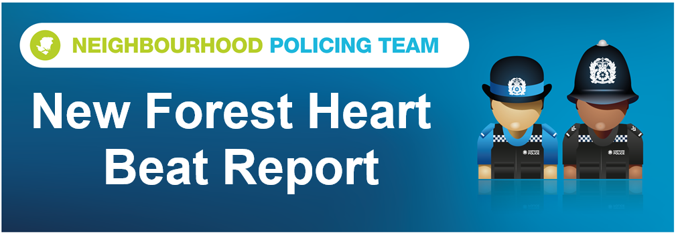

Hello and welcome to the June 2026 Beat Report for the New Forest Heart area. Your team is PC 24901 Mark ROBERTS, PC 27901 Stuart READHEAD and PCSO 14495 Richard WILLIAMS.
On Sunday 5th between 11am and 12.30pm we will be outside the Boost Bike Hub in Brockenhurst for another of our bike marking session. Bring your bikes to us and we will security mark them for free and add them to the national bike register.
On Tuesday 14th July we will be at the Bramshaw Village Shop at 8am, at the Bartley Post Office at 9am and then in the Happy Cheese Pub in Ashurst with the Ashurst and Colbury Neighbourhood watch team at 11am and an hour later at midday on Brookley Road in Brockenhurst, just opposite Tesco.
On Wednesday 15th we will be at the Lyndhurst Parish Council Offices at 11am.
We are also holding two more SCAM BUSTING talks in July, the first is at Poulner Baptist Church, Linford Road, Ringwood, BH24 3HZ on Wednesday 8th at 1.30pm and the second is in the Lymington Community Centre at 10.30 on Friday 10th.
Our Beat Surgeries last for 30 minutes, unless demand is high of course, but as we always say if you can’t come to any of these meetings you can always call or email us, but to report a crime or any anti-social behaviour dial 101 or go the Hampshire and IOW Police website. Of course if it’s an emergency always call 999.
There has been a small increase in the number of bicycles stolen last month with several taken from across the Forest including two e bikes that were locked up at Brockenhurst railway station. We are out patrolling the most popular places for thieves to operate all the time but as much as we would like to we can’t be everywhere all the time so can we remind you to do everything you can to keep your property safe. If you have a bike use the very best D lock to secure it and if possible never leave it unattended. It’s the same when you leave your vehicle unattended anywhere. Please take all of your valuables with you when you leave your car and don’t hide them in the boot either because you never know who is watching you. The holiday season brings thieves as well as visitors to the Forest so please spread the word and if you would like one of our NO VALUABLES HAVE BEEN LEFT IN THIS VEHCILE cards email richard.williams@hampshire.police.uk and we will send you one.
Other thefts this month include a parcel from a porch in Ashurst, £150 worth of petrol from a drive off in Cadnam, motorbikes on Deerleap Lane and in Bramshaw and two catalytic converters from vehicles parked overnight on Penn Common and in Ashurst. A shed on the outskirts of Calmore was broken into and an electric bike and several tools stolen and an attempt was made to break into a pub in Cadnam overnight but the thieves didn’t get in
Forestry England have also reported that more of their car parking signs have either been damaged or stolen from dozens of car parks – again if you know who is doing this please let us know. Damage has also been caused to a building site in Ashurst and there have been two shopliftings, both in Lyndhurst. A dress was stolen from a shop on the High Street and a large amount of chocolate and other items were taken from Tesco
Elsewhere in June an E bike was seized by our Roads Policing Team just outside Lyndhurst, a fire was started deliberately in the Dibden Inclosure and paint was thrown over a shop front in Lyndhurst.
Last month we told you about some concerning behaviour in the fields along Chineham Road in Bartley. On one occasion a horse in one of the fields was injured and now we have heard that a cat from the same area was shot and sadly died as a result of its injuries. Please contact us if you have any information that will help us identify who is responsible. Please contact PCSO Williams on the email provided or call 101 and quote the incident number 44260237632. Thank you
Stay safe everyone
richard.williams@hampshire.police.uk
07554 775469

mark.roberts.2@hampshire.police.uk
07392 314340



